Ставим PIP и DBT:
sudo apt-get install python3-pip

pip install --upgrade setuptools wheel

pip install dbt-core

pip install dbt-clickhouse

dbt --version

mkdir /imdb
cd /imdb
dbt init imdb

В clickhouse-client создаем таблицы:
CREATE DATABASE imdb;

CREATE TABLE imdb.actors
(
id UInt32,
first_name String,
last_name String,
gender FixedString(1)
) ENGINE = MergeTree ORDER BY (id, first_name, last_name, gender);

CREATE TABLE imdb.directors
(
id UInt32,
first_name String,
last_name String
) ENGINE = MergeTree ORDER BY (id, first_name, last_name);

CREATE TABLE imdb.genres
(
movie_id UInt32,
genre String
) ENGINE = MergeTree ORDER BY (movie_id, genre);

CREATE TABLE imdb.movie_directors
(
director_id UInt32,
movie_id UInt64
) ENGINE = MergeTree ORDER BY (director_id, movie_id);

CREATE TABLE imdb.movies
(
id UInt32,
name String,
year UInt32,
rank Float32 DEFAULT 0
) ENGINE = MergeTree ORDER BY (id, name, year);

CREATE TABLE imdb.roles
(
actor_id UInt32,
movie_id UInt32,
role String,
created_at DateTime DEFAULT now()
) ENGINE = MergeTree ORDER BY (actor_id, movie_id);

Далее грузим данные:
INSERT INTO imdb.actors
SELECT *
FROM s3('https://datasets-documentation.s3.eu-west-3.amazonaws.com/imdb/imdb_ijs_actors.tsv.gz',
'TSVWithNames');

INSERT INTO imdb.directors
SELECT *
FROM s3('https://datasets-documentation.s3.eu-west-3.amazonaws.com/imdb/imdb_ijs_directors.tsv.gz',
'TSVWithNames');

INSERT INTO imdb.genres
SELECT *
FROM s3('https://datasets-documentation.s3.eu-west-3.amazonaws.com/imdb/imdb_ijs_movies_genres.tsv.gz',
'TSVWithNames');

INSERT INTO imdb.movie_directors
SELECT *
FROM s3('https://datasets-documentation.s3.eu-west-3.amazonaws.com/imdb/imdb_ijs_movies_directors.tsv.gz',
'TSVWithNames');

INSERT INTO imdb.movies
SELECT *
FROM s3('https://datasets-documentation.s3.eu-west-3.amazonaws.com/imdb/imdb_ijs_movies.tsv.gz',
'TSVWithNames');

INSERT INTO imdb.roles(actor_id, movie_id, role)
SELECT actor_id, movie_id, role
FROM s3('https://datasets-documentation.s3.eu-west-3.amazonaws.com/imdb/imdb_ijs_roles.tsv.gz',
'TSVWithNames');

Проверяем, что все загрузилось:

SELECT id,
any(actor_name) as name,
uniqExact(movie_id) as num_movies,
avg(rank) as avg_rank,
uniqExact(genre) as unique_genres,
uniqExact(director_name) as uniq_directors,
max(created_at) as updated_at
FROM (
SELECT imdb.actors.id as id,
concat(imdb.actors.first_name, ' ', imdb.actors.last_name) as actor_name,
imdb.movies.id as movie_id,
imdb.movies.rank as rank,
genre,
concat(imdb.directors.first_name, ' ', imdb.directors.last_name) as director_name,
created_at
FROM imdb.actors
JOIN imdb.roles ON imdb.roles.actor_id = imdb.actors.id
LEFT OUTER JOIN imdb.movies ON imdb.movies.id = imdb.roles.movie_id
LEFT OUTER JOIN imdb.genres ON imdb.genres.movie_id = imdb.movies.id
LEFT OUTER JOIN imdb.movie_directors ON imdb.movie_directors.movie_id = imdb.movies.id
LEFT OUTER JOIN imdb.directors ON imdb.directors.id = imdb.movie_directors.director_id
)
GROUP BY id
ORDER BY num_movies DESC
LIMIT 5;

Далее инициализируем проект:

dbt init imdb
cd imdb

Создаем профиль dbt:
mcedit dbt_project.yml

В него добавляем строку
profile: 'clickhouse_imdb'

imdb:
actors:
+materialized: view
Далее редактируем файл
mcedit ~/.dbt/profiles.yml
И записываем в него параметры подключения к Clickhouse:
clickhouse_imdb:
target: dev
outputs:
dev:
type: clickhouse
schema: imdb_dbt
host: localhost
port: 8123
user: default
password: ''
secure: False
Проверяем возможность подключения к Clickhouse:
dbt debug

Материализация в виде создания представления
Удаляем каталог example:
rm -rf models/example
Создаем папку models/actors с файлами:
mkdir models/actors
touch models/actors/actor_summary.sql
touch models/actors/schema.yml
Редактируем /actors/schema.yml:
mcedit models/actors/schema.yml
----------------
version: 2

sources:
- name: imdb
tables:
- name: directors
- name: actors
- name: roles
- name: movies
- name: genres
- name: movie_directors
-----------------------
Далее записываем в actor_summary:
mcedit models/actors/actors_summary.sql
---------------
{{ config(materialized='view') }}

with actor_summary as (
SELECT id,
any(actor_name) as name,
uniqExact(movie_id) as num_movies,
avg(rank) as avg_rank,
uniqExact(genre) as genres,
uniqExact(director_name) as directors,
max(created_at) as updated_at
FROM (
SELECT {{ source('imdb', 'actors') }}.id as id,
concat({{ source('imdb', 'actors') }}.first_name, ' ', {{ source('imdb', 'actors') }}.last_name) as actor_name,
{{ source('imdb', 'movies') }}.id as movie_id,
{{ source('imdb', 'movies') }}.rank as rank,
genre,
concat({{ source('imdb', 'directors') }}.first_name, ' ', {{ source('imdb', 'directors') }}.last_name) as director_name,
created_at
FROM {{ source('imdb', 'actors') }}
JOIN {{ source('imdb', 'roles') }} ON {{ source('imdb', 'roles') }}.actor_id = {{ source('imdb', 'actors') }}.id
LEFT OUTER JOIN {{ source('imdb', 'movies') }} ON {{ source('imdb', 'movies') }}.id = {{ source('imdb', 'roles') }}.movie_id
LEFT OUTER JOIN {{ source('imdb', 'genres') }} ON {{ source('imdb', 'genres') }}.movie_id = {{ source('imdb', 'movies') }}.id
LEFT OUTER JOIN {{ source('imdb', 'movie_directors') }} ON {{ source('imdb', 'movie_directors') }}.movie_id = {{ source('imdb', 'movies') }}.id
LEFT OUTER JOIN {{ source('imdb', 'directors') }} ON {{ source('imdb', 'directors') }}.id = {{ source('imdb', 'movie_directors') }}.director_id
)
GROUP BY id
)

select *
from actor_summary
-------------------
В actor_summary добавлен столбец updated_at. Пока он не используется, понадобится позже.
Запускаем dbt run в каталоге imdb:
dbt run
Появилась новая база данных imdb_dbt
SHOW DATABASES;
И появилось представление actor_summary:
SELECT * FROM imdb_dbt.actor_summary ORDER BY num_movies DESC LIMIT 5;

Материализация в виде создания таблицы
Изменяем файл
mcedit models/actors/actor_summary.sql
Меняем верхнюю строку на
{{ config(order_by='(updated_at, id, name)', engine='MergeTree()', materialized='table') }}
Далее
dbt run
Смотрим, какой код получился на создание таблицы:
SHOW CREATE TABLE imdb_dbt.actor_summary;
Можно проверить содержание таблицы:
SELECT * FROM imdb_dbt.actor_summary ORDER BY num_movies DESC LIMIT 5;

Инкрементальная материализация
First, we modify our model to be of type incremental. This addition requires:
- unique_key - To ensure the plugin can uniquely identify rows, we must provide a unique_key - in this case, the id field from our query will suffice. This ensures we will have no row duplicates in our materialized table. For more details on uniqueness constraints, see here.
- Incremental filter - We also need to tell dbt how it should identify which rows have changed on an incremental run. This is achieved by providing a delta expression. Typically this involves a timestamp for event data; hence our updated_at timestamp field. This column, which defaults to the value of now() when rows are inserted, allows new roles to be identified. Additionally, we need to identify the alternative case where new actors are added. Using the {{this}} variable, to denote the existing materialized table, this gives us the expression where id > (select max(id) from {{ this }}) or updated_at > (select max(updated_at) from {{this}}). We embed this inside the {% if is_incremental() %} condition, ensuring it is only used on incremental runs and not when the table is first constructed.
Изменяем файл
mcedit models/actors/actor_summary.sql
Добавляем в него контент:
{{ config(order_by='(updated_at, id, name)', engine='MergeTree()', materialized='incremental', unique_key='id') }}
with actor_summary as (
SELECT id,
any(actor_name) as name,
uniqExact(movie_id) as num_movies,
avg(rank) as avg_rank,
uniqExact(genre) as genres,
uniqExact(director_name) as directors,
max(created_at) as updated_at
FROM (
SELECT {{ source('imdb', 'actors') }}.id as id,
concat({{ source('imdb', 'actors') }}.first_name, ' ', {{ source('imdb', 'actors') }}.last_name) as actor_name,
{{ source('imdb', 'movies') }}.id as movie_id,
{{ source('imdb', 'movies') }}.rank as rank,
genre,
concat({{ source('imdb', 'directors') }}.first_name, ' ', {{ source('imdb', 'directors') }}.last_name) as director_name,
created_at
FROM {{ source('imdb', 'actors') }}
JOIN {{ source('imdb', 'roles') }} ON {{ source('imdb', 'roles') }}.actor_id = {{ source('imdb', 'actors') }}.id
LEFT OUTER JOIN {{ source('imdb', 'movies') }} ON {{ source('imdb', 'movies') }}.id = {{ source('imdb', 'roles') }}.movie_id
LEFT OUTER JOIN {{ source('imdb', 'genres') }} ON {{ source('imdb', 'genres') }}.movie_id = {{ source('imdb', 'movies') }}.id
LEFT OUTER JOIN {{ source('imdb', 'movie_directors') }} ON {{ source('imdb', 'movie_directors') }}.movie_id = {{ source('imdb', 'movies') }}.id
LEFT OUTER JOIN {{ source('imdb', 'directors') }} ON {{ source('imdb', 'directors') }}.id = {{ source('imdb', 'movie_directors') }}.director_id
)
GROUP BY id
)
select *
from actor_summary

{% if is_incremental() %}

-- this filter will only be applied on an incremental run
where id > (select max(id) from {{ this }}) or updated_at > (select max(updated_at) from {{this}})

{% endif %}
Запускаем dbt run, чтобы обновить модель:
dbt run
Проверяем актеров по количеству фильмов:
SELECT * FROM imdb_dbt.actor_summary ORDER BY num_movies DESC LIMIT 5;
Дальше добавляем значение в actors:
INSERT INTO imdb.actors VALUES (845466, 'Clicky', 'McClickHouse', 'M');
и в roles:
INSERT INTO imdb.roles
SELECT now() as created_at, 845466 as actor_id, id as movie_id, 'Himself' as role
FROM imdb.movies
LIMIT 910 OFFSET 10000;
Проверяем, что он реально добавился:
SELECT id,
any(actor_name) as name,
uniqExact(movie_id) as num_movies,
avg(rank) as avg_rank,
uniqExact(genre) as unique_genres,
uniqExact(director_name) as uniq_directors,
max(created_at) as updated_at
FROM (
SELECT imdb.actors.id as id,
concat(imdb.actors.first_name, ' ', imdb.actors.last_name) as actor_name,
imdb.movies.id as movie_id,
imdb.movies.rank as rank,
genre,
concat(imdb.directors.first_name, ' ', imdb.directors.last_name) as director_name,
created_at
FROM imdb.actors
JOIN imdb.roles ON imdb.roles.actor_id = imdb.actors.id
LEFT OUTER JOIN imdb.movies ON imdb.movies.id = imdb.roles.movie_id
LEFT OUTER JOIN imdb.genres ON imdb.genres.movie_id = imdb.movies.id
LEFT OUTER JOIN imdb.movie_directors ON imdb.movie_directors.movie_id = imdb.movies.id
LEFT OUTER JOIN imdb.directors ON imdb.directors.id = imdb.movie_directors.director_id
)
GROUP BY id
ORDER BY num_movies DESC
LIMIT 2;
Запускаем dbt run и убеждаемся, что актер реально появился в actor_summary:
dbt run
SELECT * FROM imdb_dbt.actor_summary ORDER BY num_movies DESC LIMIT 2;
Реально произошло следующее:
SELECT event_time, query FROM system.query_log WHERE type='QueryStart' AND query LIKE '%dbt%'
AND event_time > subtractMinutes(now(), 15) ORDER BY event_time LIMIT 100;

- The plugin creates a temporary table actor_sumary__dbt_tmp. Rows that have changed are streamed into this table.
- A new table, actor_summary_new, is created. The rows from the old table are, in turn, streamed from the old to new, with a check to make sure row ids do not exist in the temporary table. This effectively handles updates and duplicates.
- The results from the temporary table are streamed into the new actor_summary table:
- Finally, the new table is exchanged atomically with the old version via an EXCHANGE TABLES statement. The old and temporary tables are in turn dropped.
This is visualized below:
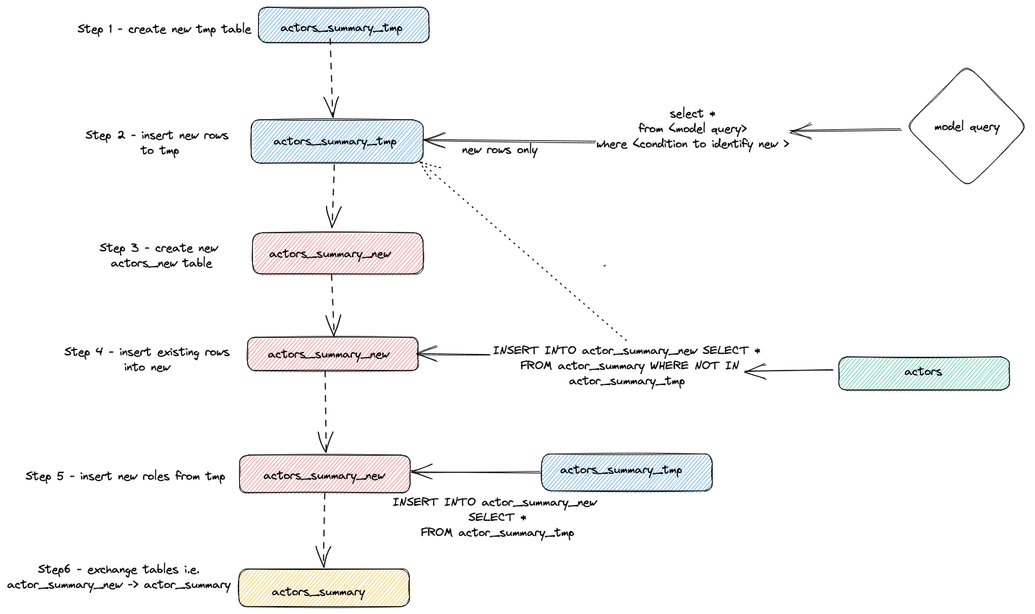

Режим добавления при инкрементальных обновлениях
To overcome the limitations of large datasets in incremental models, the plugin uses the dbt configuration parameter incremental_strategy. This can be set to the value append. When set, updated rows are inserted directly into the target table (a.k.a imdb_dbt.actor_summary) and no temporary table is created. Note: Append only mode requires your data to be immutable or for duplicates to be acceptable. If you want an incremental table model that supports altered rows don't use this mode!
В actors_summary.sql:
{{ config(order_by='(updated_at, id, name)', engine='MergeTree()', materialized='incremental', unique_key='id', incremental_strategy='append') }}
Добавляем еще актера и роли:
INSERT INTO imdb.actors VALUES (845467, 'Danny', 'DeBito', 'M');
INSERT INTO imdb.roles
SELECT now() as created_at, 845467 as actor_id, id as movie_id, 'Himself' as role
FROM imdb.movies
LIMIT 920 OFFSET 10000;
Запускаем dbt run:
dbt run
Смотрим, что получилось:
SELECT * FROM imdb_dbt.actor_summary ORDER BY num_movies DESC LIMIT 3;
Смотрим опять логи:
SELECT event_time, query FROM system.query_log WHERE type='QueryStart' AND query LIKE '%dbt%'
AND event_time > subtractMinutes(now(), 15) ORDER BY event_time LIMIT 100;
И видим, что промежуточных таблиц нет, вставка идет напрямую в actor_summary.

